Reproduce: BLITZ ET AL.(2011), Residual Momentum

Author: Dacian Peng (彭德鑫)

Written in: 2022-06

## **Data**

* 1/1/2000~6/16/2022
* ALL stocks listed on China mainland exchanges
* Monthly
* Four financial indicators: market value, book-to-market ratio, cash investment, operating profit
* close price, CSI300, one-year deposit rate (risk free rate)

## **Grouping**

* Get top 10% and bottom 10% stocks every time $t$ in Four financial indicators

e.g. $SMB_stocks$

|  |  |
| --- | --- |
| 2000-01 | [[600837.SH, 000014.SZ, 600647.SH, 600137.SH, ... |
| 2000-02 | [[600647.SH, 600137.SH, 000014.SZ, 600792.SH, ... |
| 2000-03 | [[600837.SH, 600647.SH, 000014.SZ, 600137.SH, ... |
| 2000-04 | [[600837.SH, 600647.SH, 000014.SZ, 600137.SH, ... |
| ... | ... |
| 2022-03 | [[833580.BJ, 834765.BJ, 835508.BJ, 836149.BJ, ... |
| 2022-04 | [[835508.BJ, 600091.SH, 833580.BJ, 836149.BJ, ... |
| 2022-05 | [[002473.SZ, 600890.SH, 300178.SZ, 600275.SH, ... |
| 2022-06 | [[600146.SH, 300312.SZ, 000502.SZ, 002473.SZ, ... |

Freq: M, Length: 270, dtype: object

* Average the return of the above stocks
* e.g. $SMB$ is the time sequence of **bottom** 10% market value stocks’ average return minus the **top** 10% market value stocks’ average return for every time *t*

|  |  |
| --- | --- |
| 2000-02 | -0.05403614 |
| 2000-03 | 0.090668005 |
| 2000-04 | -0.05634509 |
| ... | ... |
| 2022-03 | 0.007942155 |
| 2022-04 | -0.14957674 |
| 2022-05 | -0.00597387 |

Freq: M, Length: 270, dtype: float64

* e.g. $HML$ is the **top** bm stocks’ average return minus the **bottom** bm stocks’ average

## **Residual Momentum**

* For every stock $i$
* $y$ is the stock return time sequence (per column)

|  |  |  |  |  |  |  |
| --- | --- | --- | --- | --- | --- | --- |
|  | **000001.SZ** | **000002.SZ** | **000004.SZ** | **...** | **873169.BJ** | **873223.BJ** |
| 2000-01 | NaN | NaN | NaN | ... | NaN | NaN |
| 2000-02 | -0.01 | 0.406 | 0.011 | ... | NaN | NaN |
| 2000-03 | 0.003 | -0.144 | 0.184 | ... | NaN | NaN |
| 2000-04 | 0.038 | -0.017 | -0.043 | ... | NaN | NaN |
| ... | ... | ... | ... | ... | ... | ... |
| 2022-02 | -0.005 | -0.056 | 0.034 | ... | 0 | 0 |
| 2022-03 | -0.023 | -0.003 | -0.072 | ... | 0 | 0 |
| 2022-04 | -0.004 | 0.012 | -0.371 | ... | -0.422 | 0 |
| 2022-05 | -0.076 | -0.081 | -0.232 | ... | 0.014 | 0 |
| 2022-06 | 0.02 | 0.021 | -0.037 | ... | -0.003 | -0.579 |

270 rows × 4829 columns

* $X$ is the $constant, r_m, SMB, HML, CMA, RMW$ time matrix

|  |  |  |  |  |  |  |
| --- | --- | --- | --- | --- | --- | --- |
|  | **const** | **r_m** | **SMB** | **HML** | **CMA** | **RMW** |
| 2002-02 | 1 | 0.019 | 0.042 | -0.069 | 0.041 | -0.032 |
| 2002-03 | 1 | 0.055 | 0.029 | -0.039 | 0.059 | -0.06 |
| 2002-04 | 1 | 0.03 | 0.037 | -0.044 | 0.06 | -0.024 |
| 2002-05 | 1 | -0.085 | -0.011 | -0.058 | 0.017 | -0.023 |
| ... | ... | ... | ... | ... | ... | ... |
| 2021-11 | 1 | -0.016 | 0.068 | -0.129 | 0.108 | -0.098 |
| 2021-12 | 1 | 0.022 | 0.015 | 0.079 | 0.011 | -0.032 |
| 2022-01 | 1 | -0.076 | 0.021 | 0.055 | 0.003 | 0.003 |
| 2022-02 | 1 | 0.004 | -0.024 | -0.03 | 0.018 | 0.035 |
| 2022-03 | 1 | -0.078 | 0.008 | 0.026 | 0.05 | -0.02 |

242 rows × 6 columns

* Run the fit 4829 times
* Record the $ε$ time sequence for every stock $i$ and rolling sum it by 12 month as Residual Momentum

|  |  |  |  |  |  |  |
| --- | --- | --- | --- | --- | --- | --- |
|  | **000001.SZ** | **000002.SZ** | **000004.SZ** | **...** | **873169.BJ** | **873223.BJ** |
| 2003-01 | 0.152 | -0.211 | -0.385 | ... | NaN | NaN |
| 2003-02 | 0.156 | -0.207 | -0.344 | ... | NaN | NaN |
| 2003-03 | 0.143 | -0.062 | -0.166 | ... | NaN | NaN |
| 2003-04 | 0.118 | -0.002 | 0.09 | ... | NaN | NaN |
| ... | ... | ... | ... | ... | ... | ... |
| 2021-11 | 0.036 | -0.434 | -0.278 | ... | NaN | NaN |
| 2021-12 | 0.01 | -0.26 | -0.068 | ... | NaN | NaN |
| 2022-01 | -0.127 | -0.123 | 0.04 | ... | NaN | NaN |
| 2022-02 | -0.064 | -0.386 | 0.184 | ... | NaN | NaN |
| 2022-03 | -0.098 | -0.289 | 0.252 | ... | NaN | NaN |

231 rows × 4829 columns

## **Back Test**

* Trading fraction: 2‰
* $ε$ matrix as factor matrix
* 10 groups
* Risk-free rate assumed as p.a. 2%
* Short sell $G_{0}$, buy and hold $G_{N}$
* Redeem $G_{0}$ after 10 days, sell $G_{N}$ after 10days
* No leverage
* Initial endowment: 100,000

$$P_{T+12,b}$$

$$P_{T+2,s}$$

$$P_{T+12,s}$$

$$P_{T+2,b}$$

$$P_{T+11,b}$$

$$P_{T+1,s}$$

$$P_{T+11,s}$$

$$P_{T+1,b}$$

$$P_{T+2,b}$$

$$P_{T+1,b}$$

$$P_{T+2,s}$$

$$P_{T+1,s}$$

Cash in-flow

Cash out-flow

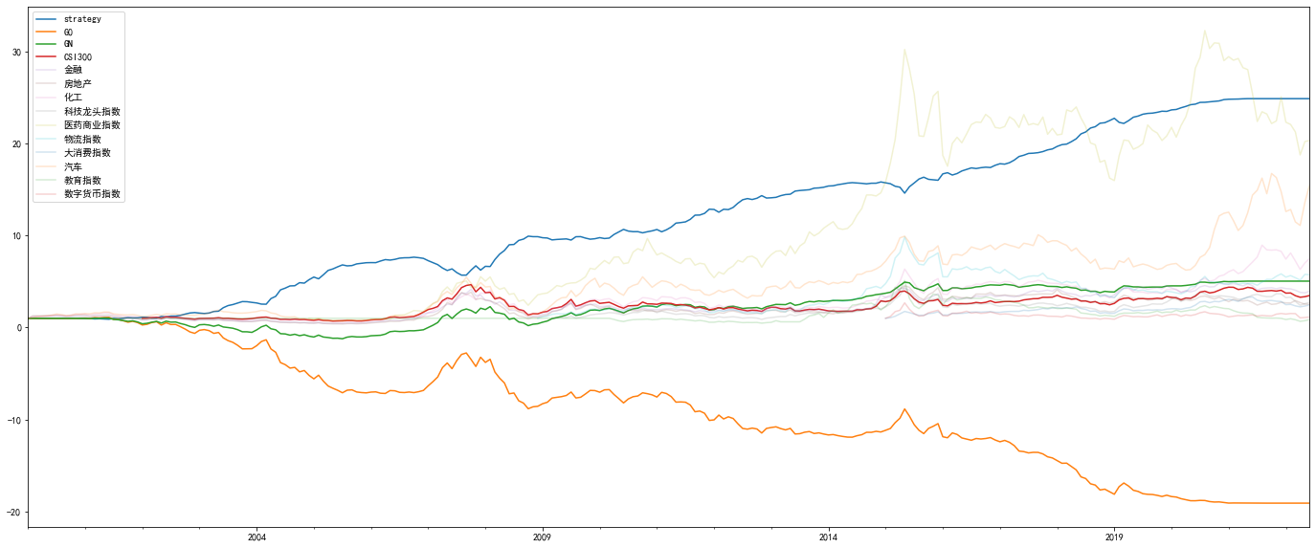

|  |  |  |  |  |  |  |  |  |  |  |  |  |
| --- | --- | --- | --- | --- | --- | --- | --- | --- | --- | --- | --- | --- |
| **daily sharpe ratio** | **daily treynor ratio** | **β** | **daily α** | **25 window MDD** | **win rate** | **calmar ratio** | **5% VaR** | **5% ES** | **compounded yearly return** | **daily std** | **CSI300 earning multiple** | **CSI300 daily volatility multiple** |
| 0.33 | -0.048 | -0.264 | 0.016 | -34.36% | 82.59% | 0.918 | 3462.605 | 4913.411 | 19.804 | 7.726 | 9.63 | 7.565 |

## **Deficiencies and Prospects**

Deficiencies:

- This work is a duplicate of *BLITZ ET AL.(2011): Residual Momentum*, I implemented methods in this paper with Fama French 5 Factor Model and China mainland data. 11 years later, it’s classical but old.

The profit in this arbitrage strategy is mainly from short-selling, but short-selling in China mainland is restricted.

I did not perform ablation study for better arbitrage strategy parameters.

Prospects:

*BLITZ ET AL.(2011): Residual Momentum* inspired the idea of residual momentum. But that’s not the point, residual is an inspiration, we should try every possible momentum factors.

Take an example, *CHAVES (2012): Eureka! A Momentum Strategy that Also Works in Japan*, author(s) used idiosyncratic volatility to construct momentum FOR THE FIRST TIME, and succeeded in a market (Japan) where most momentum strategy researches failed before.

Innovation and trials are the real useful things.

## **Acknowledgements**

Thanks for Mr. CHEN, Rui’s guidance.

I am a quant (Intern). I have a good coding skills and good network, but I ran out of ideas recently (June). I find that ideas, mathematics and data availability are limiting my career.

Literature index gave me great inspiration. After the study of asset pricing class this semester, I find that reading literature with a SORTED index and following up it really enrich my investment ideas.

In addition to reproducing the Residual Momentum in this project (individually), the team I led reproduced *GU, KELLY, AND XIU(2020) Empirical Asset Pricing via Machine Learning* in machine learning class (another course this semester, in charge of Mr. ZHANG, Ning). The literature index really helped me.

The 5 pages of momentum factor literature’ PDF are attached in the “Papers” folder or you can access it on my website <http://dacian.cc:8/files/Asset%20Pricing%20Papers/>

I also started to use EndNote for reading literature. This is a good software, but the “reference list” can only be shared to some specific e-mails, no way to make it public. If Mr. CHEN or class assistant requires, I am more than happy to share this reference list.

Thanks for Mr. CHEN’s guidance again.

## **Notes**

I skipped NA processing nor data aligning procedures in this document, you can check codes to know how I handle these situations.

The Back Test codes are developed by me during my quant intern (03/2022) this semester, other codes are developed now and here.